A Flexible, Likelihood-Based Method for Estimating Underlying Distributions, Mean and SD, Based on Reported Quantiles
Rand K^{1,2}, Estévez-Carrillo A², Janssen MF^{2,3}

¹ Health Services Research Centre, Akershus University Hospital, Lørenskog, Norway
² Maths in Health B.V., Klimmen, the Netherlands
³ Section Medical Psychology and Psychotherapy, Department of Psychiatry, Erasmus MC, Rotterdam, the Netherlands

Introduction
Meta-analysis is a widely used approach of evidence synthesis in medical research, enabling researchers to pool results across studies to obtain more precise estimates of treatment effects or group-level performance. Standard aggregate-data meta-analyses require each primary study to contribute an effect measure, typically a sample mean and corresponding measure of variability such as the standard deviation. However, studies often differ in the summary statistics they report, particularly when outcomes are skewed. As a result, many primary studies report medians together with ranges, interquartile ranges (IQRs), or other quantiles instead of means and standard deviations. This issue has been documented across diverse clinical domains [1-8].
When primary studies report medians and quantiles rather than means and standard deviations, the data cannot be directly used for meta-analysis without additional assumptions or transformation procedures. Consequently, a substantial methodological literature has emerged to estimate means and standard deviations from limited quantile information. Both formula-based [9, 10] and simulation-based [11] approaches have been proposed. Formula-based methods perform well under normality assumptions and large sample sizes. Simulation-based approaches offer greater flexibility for skewed data by allowing parametric distributions. However, these methods have their limitations, as formula-based methods can yield biased estimates when the underlying distribution deviates from normality (the very circumstance in which authors tend to report medians), while simulation-based methods can be computationally burdensome and sensitive to user-defined modelling choices. These limitations are pronounced in fields where reporting practices are heterogeneous, as in the speech-in-noise literature. For example, Gifford et al. (2019) reported the sample size, mean, and range for adaptive HINT speech-reception thresholds (SRT), whereas other studies in the same evidence base reported variability as standard deviations or provided only quantiles [12]. Effective data harmonization therefore requires methods capable of accommodating diverse forms of summary statistics and capturing non-normal distributional shapes.
McGrath et al. (2020) proposed two optimization-based methods for estimating the sample mean and standard deviation from reported quantiles when the underlying distribution is potentially skewed [13]. The Box–Cox (BC) method applies a power transformation to the reported quantiles and selects the transformation that best approximates normality, after which existing normal-theory estimators are used to compute the mean and standard deviation. The Quantile Estimation (QE) method fits candidate parametric distributions by minimizing the discrepancy between observed and theoretical quantiles and derives the mean and standard deviation from the best-fitting distribution. Both approaches avoid closed-form formula assumptions and are computationally more flexible than traditional methods, while remaining less intensive than full simulation-based techniques.
The methods by Luo and Wan are directly applicable only in cases where normality can be expected. They are also approximations that are very accurate for high n, but not as accurate with few observations. The QE method will tend to over-weigh the impact of the min/max observations. To address these challenges, we propose a unified interval regression (IR) approach for estimating the most likely underlying distribution from any combination of reported quantiles. Rather than restricting analysis to a small number of predefined scenarios, the IR framework leverages the likelihood of observing each reported quantile, based on a general form of the probability density and cumulative distribution functions. This allows flexible evaluation of multiple distributional families, including but not limited to the normal, Weibull, gamma, and log-normal distributions, and yields maximum-likelihood estimates of means and standard deviations even when only partial quantile information is available.
The objectives of this paper are twofold. First, to introduce and formalize the interval regression approach as a flexible alternative for harmonizing summary statistics; and second, to evaluate the performance of the IR method through an empirical application.
Methods
Aggregate-data meta-analyses of continuous outcomes require study-level estimates of the mean, variance, and sample size for each study or study arm. However, primary studies frequently report alternative summary statistics, including medians, ranges, inter-quartile ranges (IQRs), or selected quantiles, often reflecting skewness in the underlying outcome distribution. Data harmonization is therefore required to obtain consistent summary measures prior to meta-analysis.
To describe the different approaches, we focus on a typically discussed setting in which a study reports the sample size $N$and one of three standard configurations of quantile information:
- Scenario 1 (S1): minimum, median, and maximum $\left(Q_{min} , Q_{2} , Q_{max}\right)$;
- Scenario 2 (S2): first quartile, median, and third quartile $\left(Q_{1} , Q_{2} , Q_{3}\right)$;
- Scenario 3 (S3): minimum, first quartile, median, third quartile, and maximum $\left(Q_{min} , Q_{1} , Q_{2} , Q_{3} , Q_{max}\right)$.
These scenarios correspond to reporting patterns often addressed in the existing literature.
Existing methods for mean and standard deviation estimation
Several methods have been proposed to estimate the sample mean and standard deviation from reported quantiles. Among recent approaches, the formula-based estimators developed by Wan et al. (2014) and Luo et al. (2018), and the optimization-based methods proposed by McGrath et al. (2020), are the most widely used.
Mean estimation under normality (Luo et al., 2018)
Luo et al. derived improved estimators of the sample mean under the assumption of approximate normality. The estimator is expressed as a weighted combination of reported quantiles, with weights depending on the sample size $n=N-1$:
$$\hat{x}=\left(\frac{4}{4+n^{0.75}}\right)\frac{Q_{min}+Q_{max}}{2}+\left(\frac{n^{0.75}}{5+n^{0.75}}\right){Q_{2}}_{ } in S1$$
$$\hat{x}=\left(0.7\frac{0.39}{n}\right)\frac{Q_{1}+Q_{3}}{2}+\left(0.3-\frac{0.39}{n}\right){Q_{2}}_{ } in S2$$
$$\hat{x}=\left(\frac{2.2}{2.2+n^{0.75}}\right)\frac{Q_{min}+Q_{max}}{2}+\left(0.7\frac{0.72}{n^{0.55}}\right)\frac{Q_{1}+Q_{3}}{2}+\left(0.3-\frac{0.72}{n^{0.55}}-\frac{2.2}{2.2+n^{0.75}}\right){Q_{2}}_{ }\left(\frac{n^{0.75}}{5+n^{0.75}}\right){Q_{2}}_{ } in S3$$
These estimators perform well when the outcome distribution is close to symmetric.
Standard deviation estimation under normality (Wan et al., 2014)
Wan et al. derived estimators of the sample standard deviation based on order-statistic theory under normality:
$$\hat{s}=\frac{Q_{max}-Q_{min}}{2Φ^{-1} \left(\frac{n-0.375}{n+0.25}\right)} in S1$$
$$\hat{s}=\frac{Q_{3}-Q_{1}}{2Φ^{-1} \left(\frac{0.75n-0.125}{n+0.25}\right)} in S2$$
$$\hat{s}=\frac{Q_{max}-Q_{min}}{4Φ^{-1} \left(\frac{n-0.375}{n+0.25}\right)}+\frac{Q_{3}-Q_{1}}{4Φ^{-1} \left(\frac{0.75n-0.125}{n+0.25}\right)} in S3$$
where $Φ^{-1}(⋅)$denotes the inverse standard normal cumulative distribution function.
These methods are widely used but rely on approximate normality and tend to perform best for large sample sizes.
Optimization-based methods (McGrath et al., 2020)
Recognizing that quantiles are often reported for skewed outcomes, McGrath et al. proposed two optimization-based approaches.
Box–Cox (BC) approach
The BC approach applies a Box–Cox transformation to the reported quantiles, selecting the transformation parameter that makes the transformed quantiles closest to normally distributed. After transformation, the mean is estimated using the method of Luo et al. (2018) and the standard deviation using the method of Wan et al. (2014), followed by inverse transformation.
Quantile estimation (QE) approach
The QE approach fits candidate parametric distributions by minimizing the squared distance between observed and theoretical quantiles. Let $F_{θ}^{-1}(p)$denote the quantile function of a distribution parameterized by $θ$. The objective function for each scenario is:
$$S\left(θ\right)={\left(F_{θ}^{-1}\left(\frac{1}{n}\right)-Q_{min}\right)}^{2}+{\left(F_{θ}^{-1}\left(0.5\right)-Q_{2}\right)}^{2}+{\left(F_{θ}^{-1}\left(1-\frac{1}{n}\right)-Q_{max}\right)}^{2} in S1$$
$$S\left(θ\right)={\left(F_{θ}^{-1}\left(0.25\right)-Q_{1}\right)}^{2}+{\left(F_{θ}^{-1}\left(0.5\right)-Q_{2}\right)}^{2}+{\left(F_{θ}^{-1}\left(0.75\right)-Q_{3}\right)}^{2} in S2$$
$$S\left(θ\right)={\left(F_{θ}^{-1}\left(\frac{1}{n}\right)-Q_{min}\right)}^{2}+{\left(F_{θ}^{-1}\left(0.25\right)-Q_{1}\right)}^{2}+{\left(F_{θ}^{-1}\left(0.5\right)-Q_{2}\right)}^{2}+{\left(F_{θ}^{-1}\left(0.75\right)-Q_{3}\right)}^{2}+{\left(F_{θ}^{-1}\left(1-\frac{1}{n}\right)-Q_{max}\right)}^{2} in S3$$
The fitted distribution is then used to derive the implied mean and standard deviation.
Limitations of existing approaches
Existing methods are constrained to the three canonical reporting scenarios described above, whereas empirical reporting practices are considerably more heterogeneous. Formula-based methods assume approximate normality and may be inaccurate for small sample sizes. The QE approach can be sensitive to extreme quantiles, particularly the minimum and maximum, which may receive disproportionate influence in the fitting procedure.
Interval regression (IR) approach
To address these limitations, we propose a unified likelihood-based method for identifying the most plausible underlying distribution given arbitrary reported quantile information. The approach generalizes order-statistic likelihoods to interval-censored data.
Let $ϕ(⋅)$and $Φ(⋅)$denote the probability density function (PDF) and cumulative distribution function (CDF) of a candidate distribution. Consider $m$reported quantiles with probabilities $q_{1},…,q_{m}$and observed values $Q_{1},…,Q_{m}$. Let $N$denote the sample size and $n=N-1$. The expected rank of quantile $q_{i}$is
$$r(q_{i})=nq_{i}+1,$$
and the expected number of observations falling between adjacent quantiles defines $m+1$intervals.
The likelihood contribution of the quantiles and the intervals is
$$p\left(q\right)=Φ{\left(Q_{1}\right)}^{o\left(1\right)}ϕ\left(Q_{1}\right){\left(Φ\left(Q_{2}\right)-Φ\left(Q_{1}\right)\right)}^{o\left(2\right)}ϕ\left(Q_{2}\right)… {\left(Φ\left(Q_{m}\right)-Φ\left(Q_{\left(m-1\right)}\right)\right)}^{o\left(m\right)}ϕ\left(Q_{m}\right){\left(1-Φ\left(Q_{m+1}\right)\right)}^{o\left(m+1\right)}$$
with $Q_{0}=-∞$, $Q_{m+1}=∞$, and $o(i)$denoting the expected number of observations in interval $i$.
The corresponding log-likelihood is
$$log\left(p\left(q\right)\right)=\sum_{i=1}^{m}{\left[log\left(ϕ\left(Q_{i}\right)\right)\right]}+\sum_{i=1}^{m+1}{\left[o(i)log⁡\left(Φ\left(Q_{i}\right)-Φ\left(Q_{(i-1)}\right)\right)\right]}$$
Model parameters are estimated by maximizing this log-likelihood over a set of candidate distributions. The fitted distribution directly yields the implied mean and variance without requiring normality assumptions or predefined reporting scenarios.
Performance evaluation
The IR method was compared to the quantile estimation and box-cox approaches developed by McGrath 2020 using simulated data as in McGrath 2020, drawn randomly nine different distributions, with between 25 and 1000 observations.
The distributional cases reported in the literature are presented in Table 1. Sample sizes were varied between 25 and 1000. 1000 samples of each type of each sample size.
The methods were compared in terms of Average Relative Error $\left(ARE\left(\hat{x}\right)=\frac{1}{n}\sum_{i=1}^{n}{\frac{\hat{x_{i}}-\overline{x_{i}}}{\overline{x_{i}}}}\right)$ , and Absolute Relative Error $\left(AbsRE\left(\hat{x}\right)=\frac{1}{n}\sum_{i=1}^{n}{\frac{abs\left(\hat{x_{i}}-\overline{x_{i}}\right)}{\overline{x_{i}}}}\right)$.

Results
As shown in Figure 1, the likelihood-based approach performed as well or better than the best available alternative methods in all the simulated cases, is applicable to other situations. Figure 2 illustrates the presentation of results using the interval regression approach.

Discussion
This paper introduced a unified interval regression (IR) approach for estimating means and standard deviations from heterogeneous sets of reported quantiles and evaluated its performance relative to existing optimization-based methods. The results demonstrate that the proposed likelihood-based framework performs at least as well as, and in many settings better than, established alternatives across a wide range of distributional shapes and sample sizes. Importantly, the IR approach achieves this without relying on restrictive normality assumptions or predefined reporting scenarios, thereby addressing a key limitation of existing methods used in aggregate-data meta-analysis.
Across the simulation study, the IR method consistently showed favorable performance in terms of both average relative error and absolute relative error for the mean and variance estimates. Its advantages were particularly evident in settings involving skewed distributions and heterogeneous quantile reporting, which reflect common empirical practice in clinical research. While the Box–Cox and quantile estimation (QE) approaches of McGrath et al. offer improvements over traditional formula-based estimators under non-normality, their performance depends on transformation choices, sensitivity to extreme quantiles, and scenario-specific formulations. In contrast, the IR framework directly models the likelihood of observing the reported quantiles and the implied intervals between them, allowing the full information content of the reported summaries to be incorporated in a coherent probabilistic manner.

Conclusion
The IR approach outperforms methods currently used in meta and network-meta-analyses and allows for estimation of underlying distributions in cases not previously supported. Application of this method will allow inclusion of previously excluded studies in evidence synthesis. These contributions aim to improve the accuracy and robustness of meta-analytic synthesis in fields where non-standard and heterogeneous reporting practices are common.

References
- Chen K, Xu XW, Zhang RC, et al. Systematic review and meta-analysis of laparoscopy-assisted and open total gastrectomy for gastric cancer. World J Gastroenterol 2013; 19: 5365–5376.
- Maffiuletti NA, Roig M, Karatzanos E, et al. Neuromuscular electrical stimulation for preventing skeletal-muscle weakness and wasting in critically ill patients: a systematic review. BMC Med 2013; 11: 137.
- Siemieniuk RA, Meade MO, Alonso-Coello P, et al. Corticosteroid therapy for patients hospitalized with communityacquired pneumonia: a systematic review and meta-analysis. Ann Intern Med 2015; 163: 519–528.
- Grocott MP, Dushianthan A, Hamilton MA, et al. Perioperative increase in global blood flow to explicit defined goals and outcomes after surgery: a Cochrane Systematic Review. Br J Anaesth 2013; 111: 535–548.
- Dasari BV, Tan CJ, Gurusamy KS, et al. Surgical versus endoscopic treatment of bile duct stones. Cochrane Database Syst Rev 2013; 12: CD003327.
- Xie X, Pan L, Ren D, et al. Effects of continuous positive airway pressure therapy on systemic inflammation in obstructive sleep apnea: a meta-analysis. Sleep Med 2013; 14: 1139–1150.
- Cucchetti A, Cescon M, Ercolani G, et al. A comprehensive meta-regression analysis on outcome of anatomic resection versus nonanatomic resection for hepatocellular carcinoma. Ann Surg Oncol 2012; 19: 3697–3705.
- de Kieviet JF, Piek JP, Aarnoudse-Moens CS, et al. Motor development in very preterm and very low-birth-weight children from birth to adolescence: a meta-analysis. JAMA 2009; 302: 2235–2242.
- Wan X, Wang W, Liu J, et al. Estimating the sample mean and standard deviation from the sample size, median, range and/or interquartile range. BMC Med Res Methodol 2014; 14: 135.
- Luo D, Wan X, Liu J, et al. Optimally estimating the sample mean from the sample size, median, mid-range, and/or midquartile range. Stat Methods Med Res 2018; 27: 1785–1805.
- Kwon D and Reis IM. Simulation-based estimation of mean and standard deviation for meta-analysis via Approximate Bayesian Computation (ABC). BMC Med Res Methodol 2015; 15: 61.
- Gifford
- McGrath S, Zhao X, Steele R, Thombs BD, Benedetti A; DEPRESsion Screening Data (DEPRESSD) Collaboration. Estimating the sample mean and standard deviation from commonly reported quantiles in meta-analysis. Stat Methods Med Res. 2020 Sep;29(9):2520-2537. doi: 10.1177/0962280219889080. Epub 2020 Jan 30. PMID: 32292115; PMCID: PMC7390706.

Table 1. Distributional Cases
Name | Distribution
Var1 | Normal,  Mean = 5, SD = 1
Var2 | Lognormal,  meanlog = 5, SDlog = 0.25
Var3 | Lognormal,  meanlog = 5, SDlog = 0.5
Var4 | Lognormal,  meanlog = 5, SDlog = 1
Var5 | Normal,  Mean = 50, SD = 17
Var6 | Lognormal,  meanlog = 4, SDlog = 0.3
Var7 | Exponential,  rate = 10
Var8 | Beta,  shape1 = 9, shape2 = 4
Var9 | Weibull,  shape = 2, scale = 35

Figure 1. Performance Evaluation
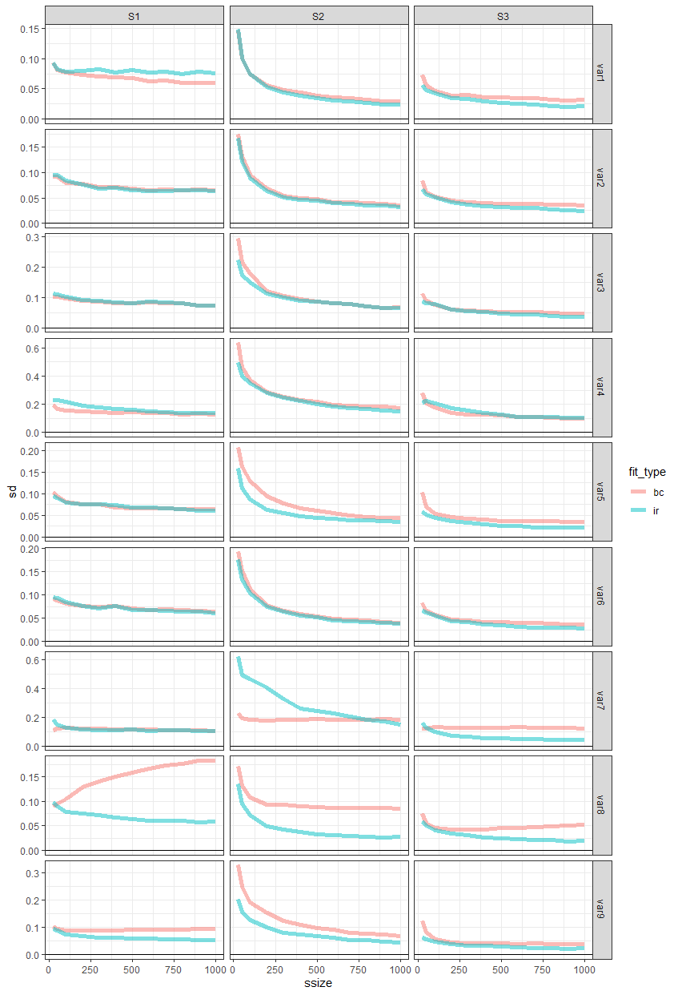

Figure 2. Graphical Presentation of Results
